Table of Contents

1. Installation/Upgrade scripts 2

2. Configuration 3

3. Installation/Update Java class for BAM 4

4. EM creation 4

5. EM change 9

6. Start and Stop EMS 17

7. Update Dashboards 20

# Installation/Upgrade scripts

This chapter explains how to install the script for the first time

* unzip bam.zip under /product/SCRIPTS/soa/;

# Configuration

This chapter explains the initial configuration script that should be done only once.

* Edit /product/Middleware/Oracle_SOA1/bam/config/BAMICommandConfig.xml in order to add username and password:

*<?xml version="1.0" encoding="UTF-8"?><BAMICommand>*

*<ADCServerName>localhost</ADCServerName>*

*<ADCServerPort>9001</ADCServerPort>*

*<Communication_Protocol>t3</Communication_Protocol>*

*<SensorFactory>oracle.bam.common.statistics.noop.SensorFactoryImpl</SensorFactory>*

*<GenericSatelliteChannelName>invm:topic/oracle.bam.messaging.systemobjectnotification</GenericSatelliteChannelName>*

***<ICommand_Default_User_Name>weblogic</ICommand_Default_User_Name><ICommand_Default_Password>current_weblogic_password </ICommand_Default_Password>***

*</BAMICommand>*

* configure envbam.sh under /product/SCRIPTS/soa/bam/ with the target env;
* run importDo.sh under /product/SCRIPTS/soa/bam/;
* run importAllChild.sh /product/SCRIPTS/soa/bam/;
* run importAllParent.sh /product/SCRIPTS/soa/bam/;

# Installation/Update Java class for BAM

This chapter explains how to install the java class

* 1. Copy SendJmsBAMPublishing.jar under **/product/Middleware/Oracle_SOA1/soa/modules/oracle.soa.ext_11.1.1**
  2. Edit SendSensorInfoConfig.properties file inside SendJmsBAMPublishing.jar with a zip program:
  3. Replace ***ttsvint1*** with name of server (ex:ttclint)
  4. Replace ***8001*** with number port of server (ex:8001)
  5. Replace ***weblogic*** with username of Weblogic Server (ex. weblogic)
  6. Replace ***weblogic!1*** with password of Weblogic Server (ex. weblogic!1)
  7. Save jar file
  8. Stop soa1 and soa2 server
  9. cd /product/Middleware/Oracle_SOA1/soa/modules/oracle.soa.ext_11.1.1
  10. /product/Middleware/modules/org.apache.ant_1.7.1/bin/ant
  11. restart soa1 and soa2 server

For update of class:

1. Copy SendJmsBAMPublishing.jar under **/product/Middleware/Oracle_SOA1/soa/modules/oracle.soa.ext_11.1.1**
2. Edit SendSensorInfoConfig.properties file inside SendJmsBAMPublishing.jar with a zip program:
   1. Replace ***ttsvint1*** with name of server (ex:ttclint)
   2. Replace ***8001*** with number port of server (ex:8001)
   3. Replace ***weblogic*** with username of Weblogic Server (ex. weblogic)
   4. Replace ***weblogic!1*** with password of Weblogic Server (ex. weblogic!1)
3. Save jar file
4. Stop soa1 and soa2 server
5. cd /product/Middleware/Oracle_SOA1/soa/modules/oracle.soa.ext_11.1.1

# EM creation

This chapter explains how to install the EM

Open Internet Explorer and go to this address http://<hostname>:<port>/OracleBAM like the screenshots below:

Create EM source with the same name of the screenshot and set all fields like this:

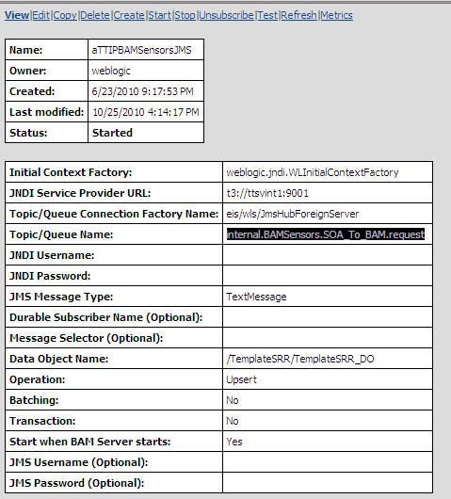

Change all <hostname> or ttsvint1 and <port> or 9001 with hostname and port of server BAM.

Past the **TrasfEM1.txt** into XSL transformation:



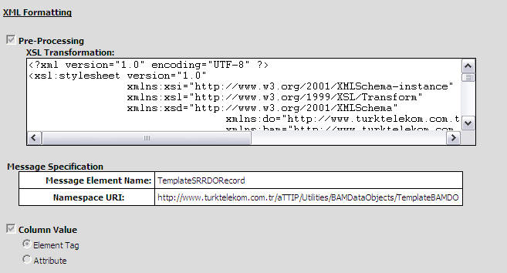

Configure all fields like below:

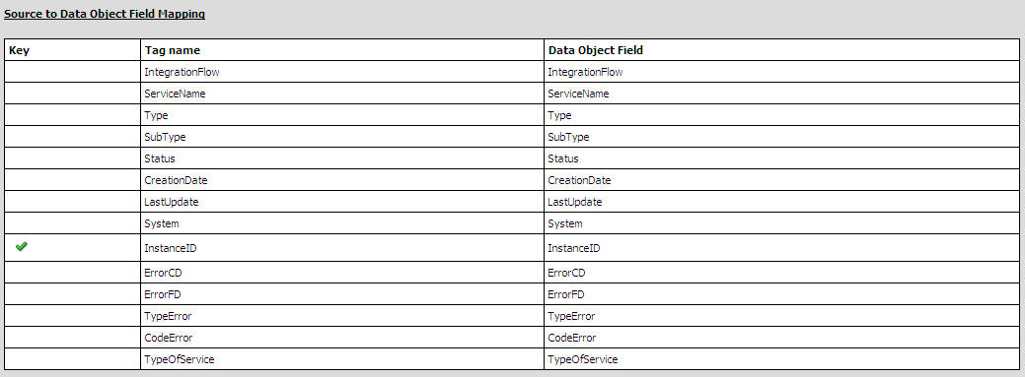

Please click on Start

All steps must be performed also for SendDataToBAM EM source:

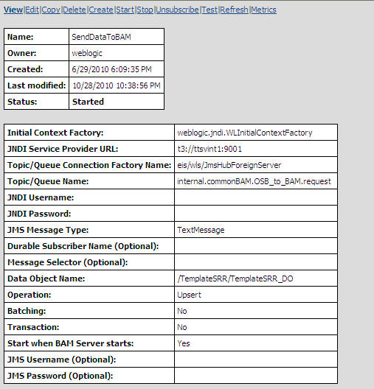



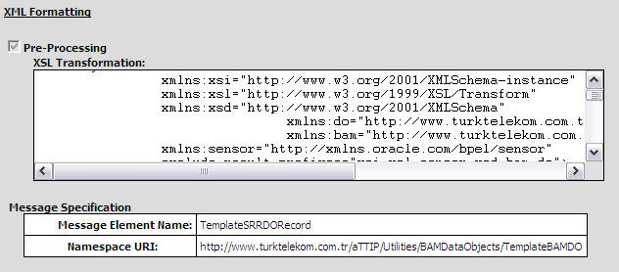

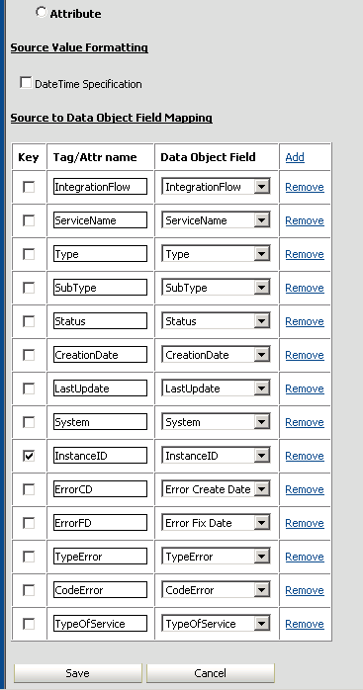

# EM change

* 1. DataObject change

Follow these steps:

1. Open Internet Explorer browser and specify the console of BAM (eg. <http://ttsvint1:9001/OracleBAM>)
2. Specify username and password
3. Click Architect

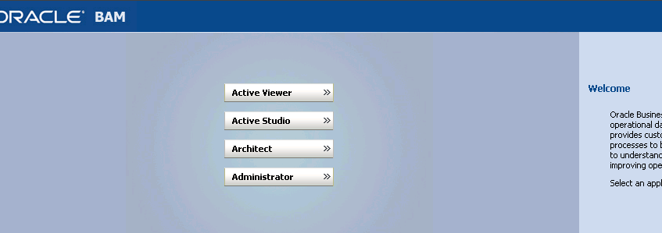

1. Choose Data objects if not already selected

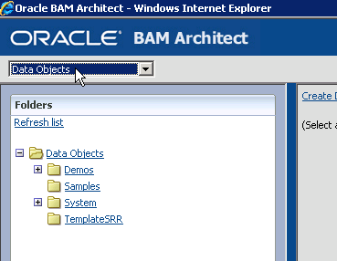

1. Choose TemplateSRR from treeview
2. Choose TemplateSRR_DO from Data Objects

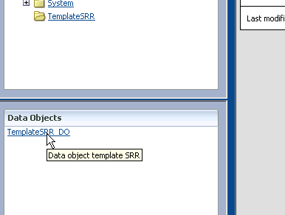

1. Click Layout

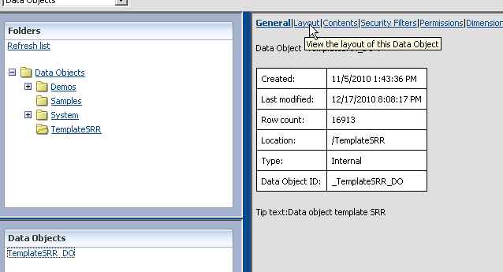

1. Click Edit Layout button

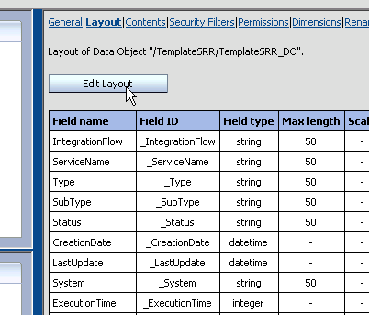

1. Click Remove on the row contains field ExecutionTime and click Save Changes

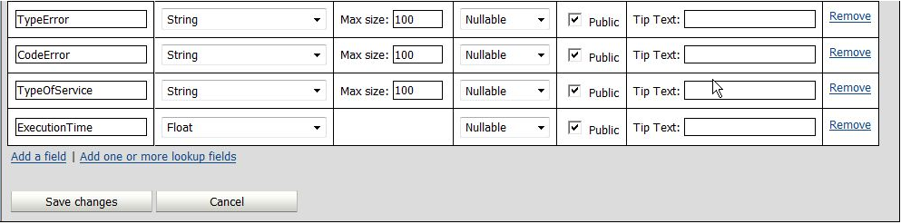

1. Click Continue
2. Repeat only step 8
3. Click Add a field

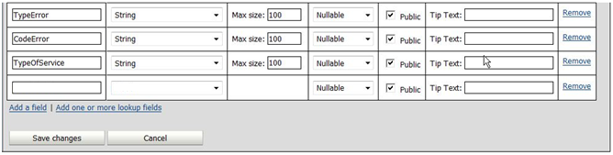

1. Specify FixedTime name (first text box of last row) and Float from first combo box
2. Repeat step 12
3. Specify ExecutionTime name (first text box of last row) and Float from combo box
4. Check if Status of all EMS (Enterprise Message Sources) is Started otherwise start it.
   1. Transformation change

Follow these steps:

1. Open Internet Explorer browser and specify the console of BAM (eg. <http://ttsvint1:9001/OracleBAM>)
2. Specify username and password
3. Click Architect
4. Choose Enterprise Message Sources

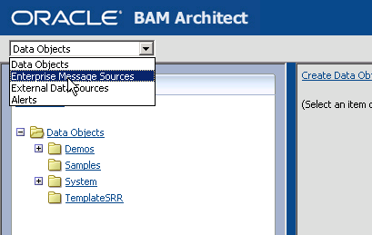

1. For Trasf1.txt click on **aTTIPBAMSensorsJMS**, for Trasf2.txt click on **SendDataToBAM**

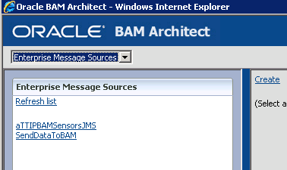

1. Click Edit – (note: the state must be "started")

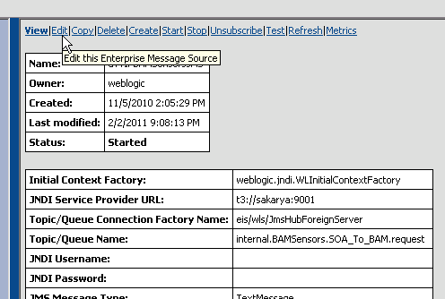

1. Click Advanced formatting options

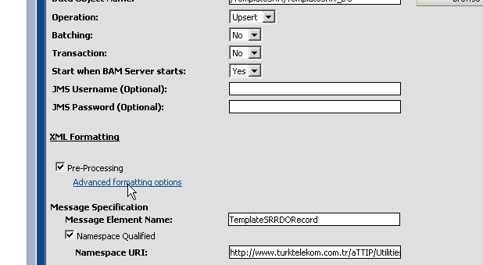

1. Clear the content of first textbox and paste the content of txt file

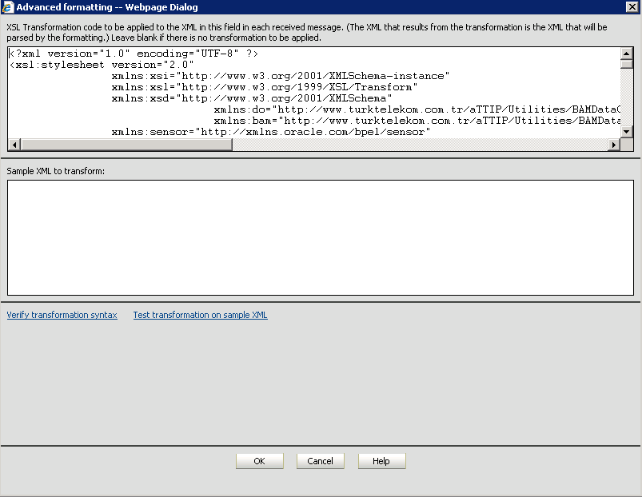

1. Click OK
2. If window is closed then is ok
3. Click Save at the bottom of the page



1. Click Continue
2. Click Start
3. Check Status is Stared

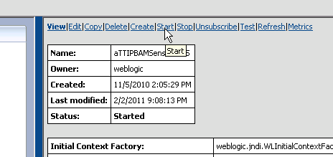

# Start and Stop EMS

Follow these steps for Start EMS:

1. Open Internet Explorer browser and specify the console of BAM (eg. <http://ttsvint1:9001/OracleBAM>)
2. Specify username and password
3. Click Architect
4. Choose Enterprise Message Sources



1. Choose the EMS to start



1. Click Start and check Status is Started



Follow these steps for Stop EMS:

1. Open Internet Explorer browser and specify the console of BAM (eg. <http://ttsvint1:9001/OracleBAM>)
2. Specify username and password
3. Click Architect
4. Choose Enterprise Message Sources



1. Choose the EMS to start



1. Click Stop and check Status is Started



# Update Dashboards

This chapter explains how to upgrade the dashboard when a fix related to a defect or an improvement is required.

* If exists **/product/SCRIPTS/soa/bam/exp_report_parent** create backup and delete
* If exists /**product/SCRIPTS/soa/bam/exp_report_child** create backup and delete
* unzip dashboard.zip under /product/SCRIPTS/soa/bam
* replace **list_del.lst** file
* run deleteAll.sh
* run importAllChild.sh /product/SCRIPTS/soa/bam/
* run importAllParent.sh /product/SCRIPTS/soa/bam/